**COMPARING PREDICTIVE MODELS FOR FORECASTING CINEMA SALES: A CASE STUDY**

**AKSHDA SHANDILYA**

**MAY 5, 2023**

INTRODUCTION

Sales forecasting plays a crucial role in business planning and decision-making across various industries. In the context of the cinema industry, accurate sales forecasting for ticket sales is of paramount importance. It allows cinema operators to optimize their resources, make informed programming decisions, and improve overall operational efficiency. However, forecasting cinema ticket sales can be challenging due to the complex and dynamic nature of the industry, influenced by factors such as movie releases, market trends, seasonality, and customer preferences.

This project aims to assess and compare different sales forecasting models for cinema ticket sales to identify the most effective and accurate approach. By utilizing advanced statistical techniques and machine learning algorithms, we aim to develop reliable models that can predict future ticket sales with a high level of accuracy. The project will focus on analyzing historical ticket sales data, market trends, and other relevant variables to train and validate the forecasting models.

To ensure the credibility and rigor of our research, we will draw upon a variety of reputable sources and references. These will include academic journals, industry reports, and scholarly publications that discuss sales forecasting methodologies and their application in the cinema industry. By incorporating this existing body of knowledge, we will leverage the expertise and insights of established researchers and industry professionals.

The outcomes of this project will have significant implications for cinema operators, distributors, and stakeholders in the film industry. Accurate sales forecasting will enable them to better anticipate demand, optimize pricing strategies, allocate resources effectively, and enhance overall customer experience. Ultimately, this research endeavor aims to provide actionable insights and recommendations that can improve the decision-making process and contribute to the long-term success and profitability of cinema businesses.

By evaluating and comparing different forecasting models, we hope to identify the most suitable approach for accurate cinema ticket sales forecasting. This will help cinema operators stay ahead in a highly competitive market, make informed decisions, and maximize their revenue potential.

LITERATURE REVIEW

Previous studies have used various techniques for sales forecasting in the cinema industry, including time series analysis, machine learning algorithms, and hybrid models. For example, a study by Li and Xie (2017) used an ARIMA (Autoregressive Integrated Moving Average) model to forecast box office revenue in China. They found that their model had a high accuracy rate and could provide valuable insights into future box office trends.

Another study by Song and Cho (2018) used a machine learning algorithm called Gradient Boosting Decision Tree to predict daily admissions in Korean cinemas. Their model was found to outperform traditional time series models and was able to accurately predict admissions up to a month in advance.

Hybrid models that combine time series analysis and machine learning techniques have also been explored. For instance, a study by Raju et al. (2020) used a hybrid model of ARIMA and Random Forest to forecast movie ticket sales in Indian cinemas. Their model was found to have a higher accuracy rate than individual models and could provide valuable insights for cinema owners in planning their resources.

Overall, these previous studies demonstrate the potential of time series analysis and machine learning techniques for sales forecasting in the cinema industry. By building on these techniques and exploring new approaches, this project aims to contribute to the field and provide valuable insights for cinema owners in managing their resources and maximizing profitability.

This project utilizes a dataset obtained from Kaggle and aims to assess sales forecasting for cinema ticket sales. Previous studies in the field have focused either on time series modeling or machine learning algorithms individually. However, this project stands out by combining both approaches to enhance the accuracy and robustness of sales forecasting. By analyzing historical ticket sales data and relevant variables, the project aims to train and evaluate various prediction models, including hybrid models that integrate both time series and machine learning techniques. The goal is to identify the most effective prediction models that can accurately forecast future ticket sales and potentially uncover new and innovative methods for sales forecasting in the cinema industry.

By conducting this study, the project seeks to make an original contribution to the field of sales forecasting for cinema ticket sales. The findings and insights gained from this research endeavor will not only benefit cinema operators but also pave the way for advancements in prediction models and methodologies in the cinema industry and beyond. Combining time series modeling and machine learning algorithms offers a comprehensive and nuanced understanding of sales forecasting, enabling informed decision-making and optimization of resources for cinema businesses.

METHODOLOGY

VARIABLE:

Following is a description for the variables used for this study:

| **Variable Name** | **Variable Type** | **Variable Description** |
| --- | --- | --- |
| **film_code** | Categorical | Encoded or anonymized identifier for the film. |
| **cinema_code** | Categorical | Encoded or anonymized identifier for the cinema. |
| **total_sales** | Numeric | Sales amount generated by the cinema. |
| **tickets_sold** | Numeric | Number of tickets sold for the film screening. |
| **tickets_out** | Numeric | Number of unsold or unused tickets. |
| **show_time** | Numeric | Duration or timing of the film screening. |
| **occu_perc** | Numeric | Occupancy percentage of the cinema during the screening. |
| **ticket_price** | Numeric | Price of a movie ticket. |

Following is the Variable Description, for all the variables in the dataset:

|  | **mean** | **std** | **min** | **25%** | **50%** | **75%** | **max** |
| --- | --- | --- | --- | --- | --- | --- | --- |
| **film_code** | 1518.985111 | 36.184450 | 1471.000 | 1485.000 | 1498.000 | 1556.000 | 1589.000 |
| **cinema_code** | 320.378427 | 159.701229 | 32.000 | 181.000 | 324.000 | 474.000 | 637.000 |
| **total_sales** | 12347280.0 | 30654860.0 | 20000.0 | 1260000.0 | 3720000.0 | 11100000.0 | 1262820000.0 |
| **tickets_sold** | 140.137570 | 279.758733 | 1.000 | 18.000 | 50.000 | 143.000 | 8499.000 |
| **tickets_out** | 0.237413 | 2.923206 | 0.000 | 0.000 | 0.000 | 0.000 | 311.000 |
| **show_time** | 3.932103 | 3.056276 | 1.000 | 2.000 | 3.000 | 5.000 | 60.000 |
| **occu_perc** | 19.965986 | 22.653445 | 0.000 | 3.750 | 10.350 | 28.210 | 147.500 |
| **ticket_price** | 81234.599886 | 33236.599278 | 483.871 | 60000.000 | 79454.235 | 100000.000 | 700000.000 |
| **ticket_use** | 139.900157 | 279.564935 | -219.000 | 18.000 | 50.000 | 143.000 | 8499.000 |
| **capacity** | 854.723605 | 953.118103 | -2.000 | 276.994 | 525.714 | 1038.961 | 9692.097 |
| **month** | 6.776852 | 2.195843 | 2.000 | 5.000 | 7.000 | 9.000 | 11.000 |
| **quarter** | 2.634721 | 0.809692 | 1.000 | 2.000 | 3.000 | 3.000 | 4.000 |
| **day** | 16.112585 | 8.949471 | 1.000 | 8.000 | 16.000 | 24.000 | 31.000 |

Statistical Summary Coding:

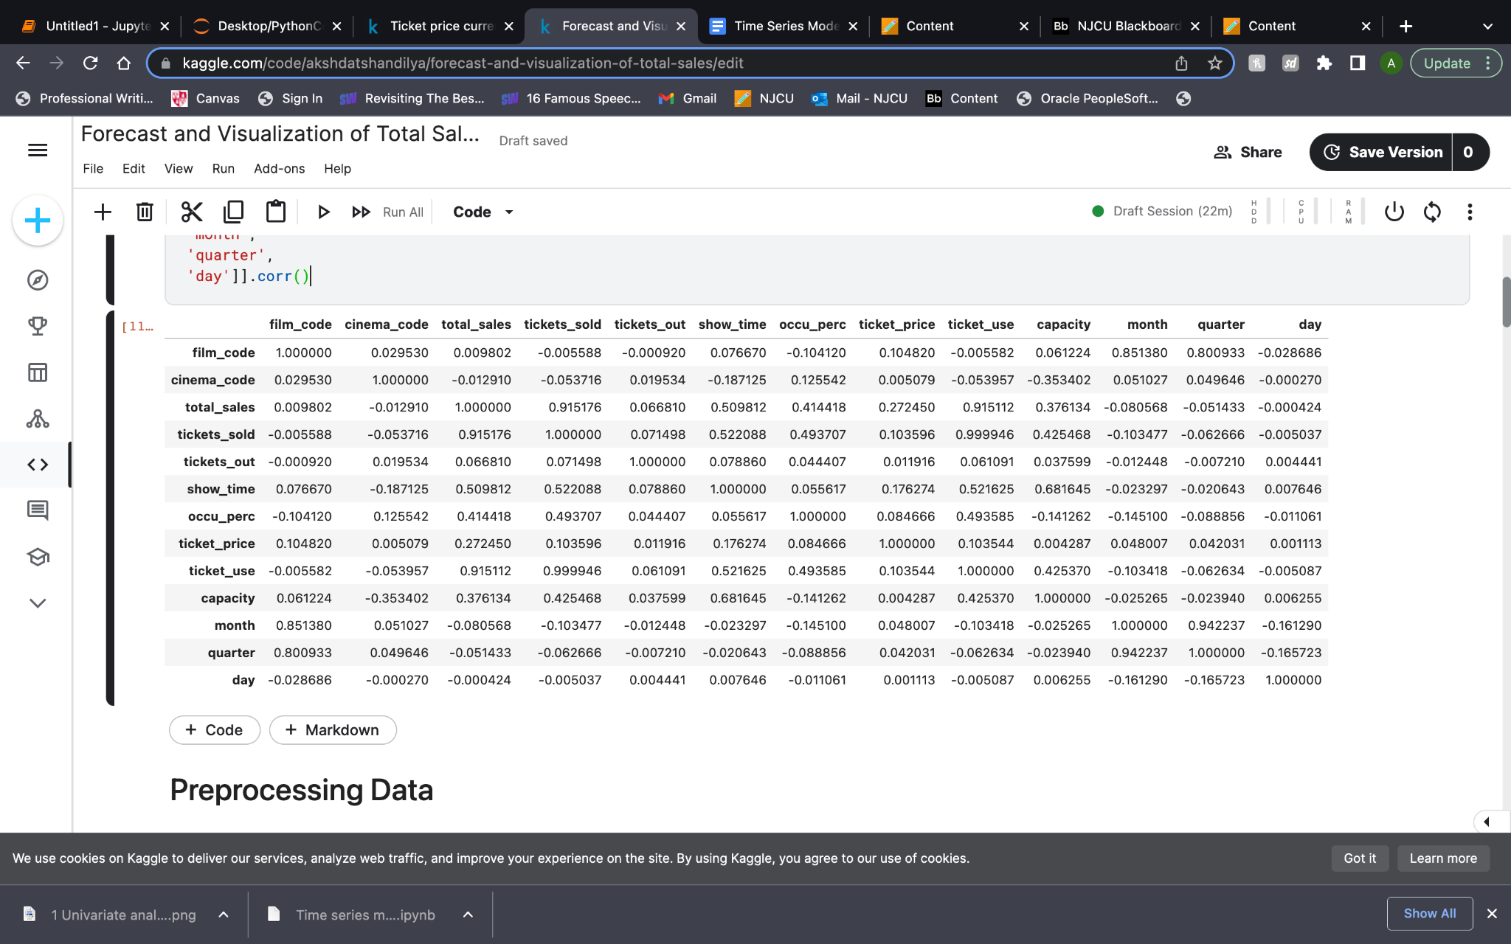

Univariate Analysis

Univariate analysis involves examining a single variable in a time series without considering other variables. Summary statistics such as mean, variance, skewness, and kurtosis can be computed using equations. For example, mean (μ) is the average of the data points, variance (σ^2) measures the spread of the data, skewness quantifies asymmetry, and kurtosis measures the shape of the distribution. Autocorrelation function (ACF) and partial autocorrelation function (PACF) equations assess the correlation between a time series and its lagged values. Lag plots visualize the correlation between a time series and its lags. These equations provide insights into the characteristics and dependencies of the time series.

Descriptive Time Series and Plotting a Time Series

Descriptive time series analysis involves examining the key characteristics and patterns present in a time series. It includes calculating summary statistics, visualizing the data, and identifying trends or patterns. Equations are not typically used in descriptive analysis, as it focuses more on graphical representations and numerical summaries. However, summary statistics such as mean, variance, skewness, and kurtosis can be computed. Time series plots, such as line plots or scatter plots, can be generated to visualize the data. Moving averages, exponential smoothing, or trend analysis techniques may also be applied to identify and describe trends. Descriptive time series analysis aims to provide a comprehensive understanding of the time series behavior without delving into complex modeling or forecasting techniques.

Plotting in time series analysis is a visual exploration of the data. A time series plot shows the relationship between the time index and the corresponding values. Mathematically, it can be represented as a plot of y(t) against t, where y(t) represents the value of the time series at time t.

Checking Original Stationarity

Stationarity is a fundamental concept in time series analysis. A time series is said to be stationary if its statistical properties, such as mean, variance, and autocovariance, remain constant over time. The Augmented Dickey-Fuller (ADF) test is commonly used to determine stationarity. The null hypothesis of the ADF test assumes the presence of a unit root, indicating non-stationarity, while the alternative hypothesis assumes stationarity. Mathematically, the ADF test can be represented as:

Δy(t) = α + βt + γy(t-1) + δΔy(t-1) + ε(t)

where Δ denotes the differencing operator, y(t) represents the time series, t is the time index, α, β, γ, and δ are parameters, and ε(t) is the error term. If the test statistic is significant and the p-value is below a certain threshold (e.g., 0.05), we reject the null hypothesis and conclude that the series is stationary.

Differencing

Differencing is a technique used in time series analysis to remove trends and make a series stationary. It involves taking the difference between consecutive observations in a time series. Mathematically, differencing can be represented as follows:

First-order differencing: Y'(t) = Y(t) - Y(t-1)

Second-order differencing: Y''(t) = Y'(t) - Y'(t-1)

where Y(t) is the value of the time series at time t, and Y'(t) and Y''(t) represent the first-order and second-order differenced series, respectively. Differencing helps in stabilizing the mean and reducing the effects of trends, making the series suitable for further analysis.

Autocorrelation and Partial Autocorrelation

Autocorrelation and partial autocorrelation are statistical measures used in time series analysis to understand the relationship between observations at different lags. Autocorrelation measures the correlation between a time series and its lagged values, while partial autocorrelation measures the correlation between a time series and its lagged values, excluding the contributions from intermediate lags.

Mathematically, autocorrelation (ACF) and partial autocorrelation (PACF) functions can be defined as:

Autocorrelation (ACF): ACF(k) = Corr(Y(t), Y(t-k))

Partial Autocorrelation (PACF): PACF(k) = Corr(Y(t), Y(t-k)|Y(t-1), Y(t-2), ..., Y(t-k+1))

where Y(t) represents the value of the time series at time t, and k represents the lag. These functions help identify the presence of correlation and determine the appropriate lag order for autoregressive and moving average components in time series modeling.

ARIMA

ARIMA (Autoregressive Integrated Moving Average) is a popular time series model that combines autoregressive (AR), differencing (I), and moving average (MA) components to capture the underlying patterns and dynamics in a time series. It is denoted as ARIMA(p, d, q), where p represents the order of the autoregressive component, d represents the order of differencing, and q represents the order of the moving average component.

The ARIMA model equation can be expressed as:

Y(t) = c + φ₁Y(t-1) + φ₂Y(t-2) + ... + φₚY(t-p) + θ₁ε(t-1) + θ₂ε(t-2) + ... + θ_qε(t-q) + ε(t)

where Y(t) represents the value of the time series at time t, c is a constant term, φ₁ to φₚ are the autoregressive coefficients, θ₁ to θ_q are the moving average coefficients, ε(t) is the error term at time t.

A residual plot is a diagnostic tool used to assess the goodness of fit of a time series model. It plots the residuals, which are the differences between the observed values and the predicted values from the model. A random and symmetric pattern in the residual plot indicates a good fit, while any discernible patterns or trends suggest that the model may not be capturing all the information in the data.

A prediction plot is used to evaluate the performance of the ARIMA model in forecasting future values. It compares the predicted values from the model with the actual values of the time series. A good prediction plot shows a close alignment between the predicted and actual values, indicating the model's ability to capture the underlying patterns and make accurate forecasts.

SARIMAX

SARIMAX (Seasonal Autoregressive Integrated Moving Average with Exogenous Variables) is an extension of the ARIMA model that incorporates both seasonal and exogenous factors. It is denoted as SARIMAX(p, d, q)(P, D, Q, s), where (p, d, q) represents the order of the non-seasonal components, (P, D, Q) represents the order of the seasonal components, and s represents the length of the seasonal cycle.

The SARIMAX model equation can be written as:

Y(t) = c + φ₁Y(t-1) + φ₂Y(t-2) + ... + φₚY(t-p) + θ₁ε(t-1) + θ₂ε(t-2) + ... + θ_qε(t-q) + ϕ₁Y(t-s) + ϕ₂Y(t-2s) + ... + ϕ_PY(t-Ps) + Θ₁ε(t-s) + Θ₂ε(t-2s) + ... + Θ_Qε(t-Qs) + ε(t) + Xβ

where Y(t) represents the value of the time series at time t, c is a constant term, φ₁ to φₚ and θ₁ to θ_q are the autoregressive and moving average coefficients for the non-seasonal components, ϕ₁ to ϕ_P and Θ₁ to Θ_Q are the autoregressive and moving average coefficients for the seasonal components, ε(t) is the error term at time t, X represents exogenous variables, and β represents the coefficients of the exogenous variables.

SARIMAX models are useful when the time series exhibits both seasonal patterns and is influenced by external factors. By incorporating seasonal and exogenous variables, SARIMAX models can provide more accurate forecasts and capture the additional dynamics present in the data.

Machine Learning

Random Forest Regressor

Random Forest Regressor is a machine learning algorithm used for regression tasks. It is an ensemble learning method that combines multiple decision trees to make predictions. Each decision tree is built using a random subset of the training data and a random subset of the features. The final prediction is obtained by averaging the predictions of all the individual trees.

The Random Forest Regressor equation can be written as: ŷ = f(X)

where ŷ represents the predicted value, f() represents the ensemble of decision trees, and X represents the input features. Each decision tree in the ensemble predicts a value based on a subset of features, and the final prediction is obtained by averaging the predictions of all the trees.

Random Forest Regressor is effective in handling complex relationships, handling missing values, and providing robust predictions. It is widely used in various domains for regression tasks due to its ability to handle nonlinearities and capture interactions between features.

Extreme Gradient Boosting

Machine learning algorithms, such as XGBoost (Extreme Gradient Boosting), use an ensemble of decision trees to make predictions. XGBoost employs a gradient-boosting framework that sequentially adds decision trees to the model, each one correcting the mistakes made by the previous trees.

The prediction made by XGBoost can be represented by the equation: ŷ = Σ(w * h(x))

where ŷ is the predicted value, w is the weight assigned to each tree's prediction, h(x) is the output of each individual decision tree, and the sum is taken over all the decision trees in the model.

XGBoost trains the ensemble by minimizing a loss function, such as the mean squared error (MSE) or cross-entropy loss, using gradient descent optimization. The gradients are computed based on the difference between the predicted values and the actual values. The XGBoost algorithm also incorporates regularization techniques, such as L1 and L2 regularization, to prevent overfitting and improve generalization performance.

By iteratively adding and updating decision trees while optimizing the loss function, XGBoost effectively learns complex patterns and interactions in the data, providing accurate predictions for regression and classification tasks.

Model Selection

Model selection is the process of choosing the best model from a set of candidate models. Several evaluation metrics are commonly used to assess the performance of different models. Some of these metrics include Mean Squared Error (MSE), Root Mean Squared Error (RMSE), Mean Absolute Error (MAE), R-squared (R2), Akaike Information Criterion (AIC), and Bayesian Information Criterion (BIC).

These metrics can be defined as follows:

MSE = (1/n) * Σ(yi - ŷi)²

RMSE = sqrt(MSE)

MAE = (1/n) * Σ|yi - ŷi|

R2 = 1 - (SSR/SST)

AIC = n * ln(MSE) + 2k

BIC = n * ln(MSE) + k * ln(n)

where yi represents the actual values, ŷi represents the predicted values, n is the number of observations, k is the number of parameters, SSR is the sum of squared residuals, and SST is the total sum of squares.

Model selection involves comparing these metrics across different models and selecting the model with the lowest values of MSE, RMSE, MAE, AIC, and BIC, and the highest value of R2. These metrics provide quantitative measures of the model's accuracy, goodness-of-fit, and complexity, allowing for objective comparison and selection of the most appropriate model for a given problem.

RESULTS

The report aims to address the importance of accurate sales forecasting in the cinema industry and presents an analysis of a dataset obtained from Kaggle. The study utilizes both time series and machine learning modeling techniques to forecast sales and assist in resource allocation, cash flow management, and growth planning.

The methodology employed includes data collection from Kaggle, where the dataset consists of variables such as film code, cinema code, total sales, tickets sold, show time, occupancy percentage, ticket price, and more. The data is preprocessed to handle missing values and ensure data integrity.

The analysis begins with univariate analysis, examining individual variables to understand their distributions, summary statistics, and identify any outliers or anomalies. Descriptive time series analysis is conducted to uncover trends, seasonality, and patterns in the data, followed by visualizations to gain insights into the overall behavior.

Univariate Analysis:

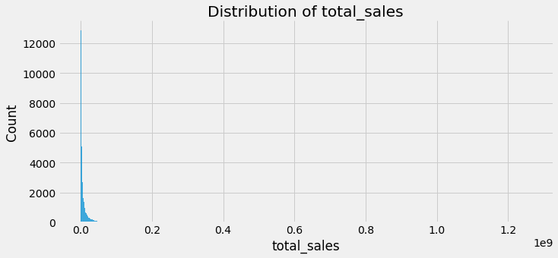

**Univariate analysis - Distribution of total_sales**

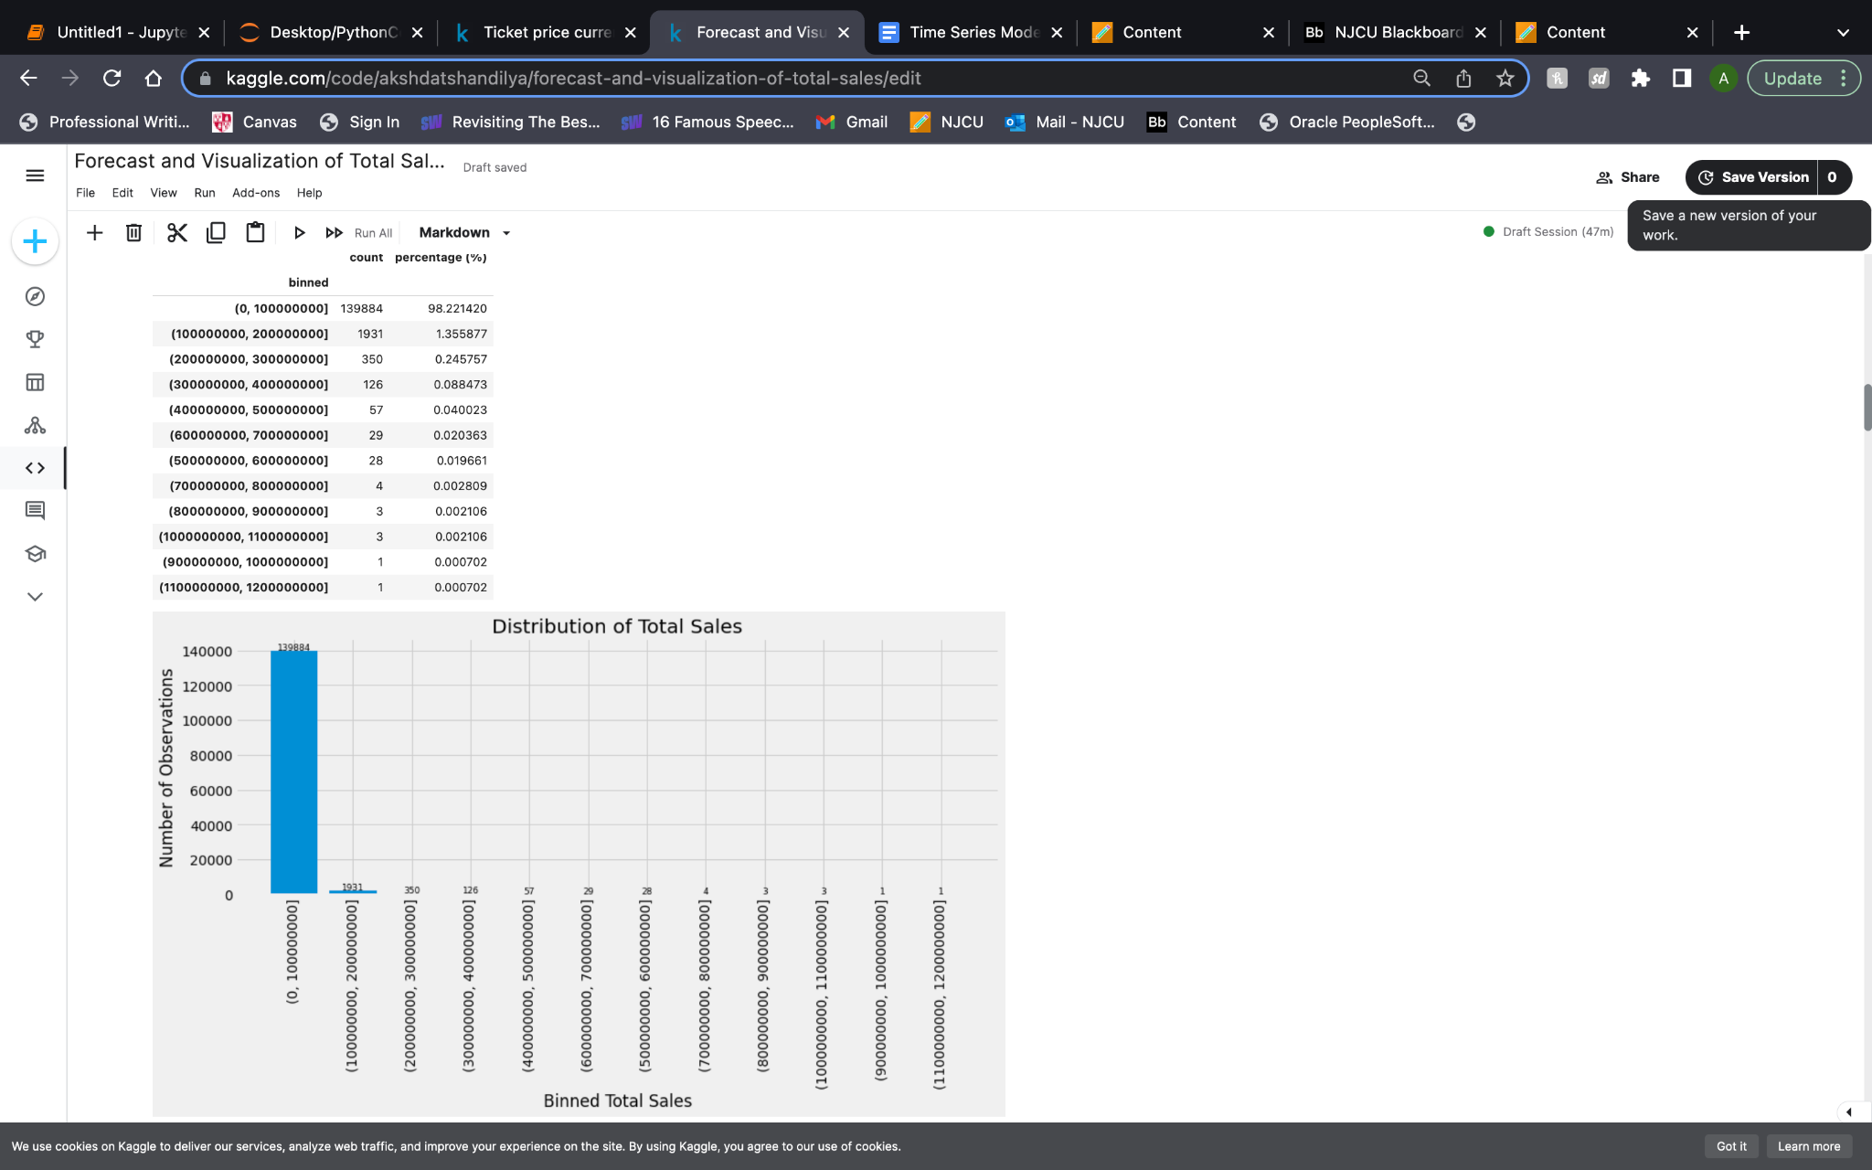

**Univariate analysis - Binned Total Sales**

| q1 | 1260000.0 |
| --- | --- |
| q3 | 11100000.0 |
| iqr | 9840000.0 |
| S | 14760000.0 |
| valid range | -13500000.0 <= total sales <= 25860000.0 |

The 'total_sales' variable in the dataset represents the total sales amount. The descriptive statistics reveal important characteristics of this variable. The data range from a minimum value of -13,500,000.0 to a maximum value of 25,860,000.0. The median value, also known as the second quartile, is 6,120,000.0, indicating that 50% of the data falls below this value. The interquartile range (IQR) measures the spread of the data and is calculated to be 9,840,000.0, with the first quartile (Q1) at 1,260,000.0 and the third quartile (Q3) at 11,100,000.0.

Furthermore, by applying Tukey's fences method, we can determine a valid range for the 'total_sales' variable, which spans from -13,500,000.0 to 25,860,000.0. Values outside this range may be considered as potential outliers. This information provides insights into the distribution and characteristics of the 'total_sales' variable, enabling further analysis and interpretation. Understanding the range, quartiles, and IQR of the data helps to identify central tendencies and potential anomalies in the sales data.

**Other metrics:**

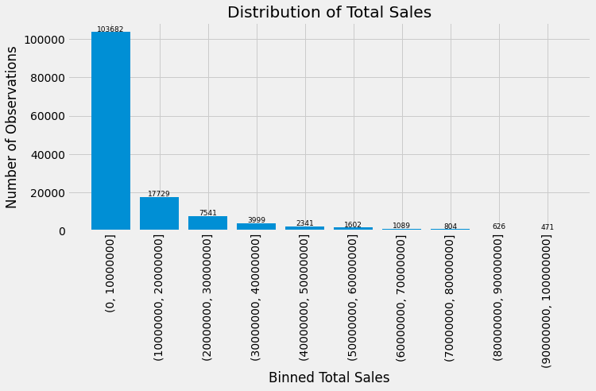 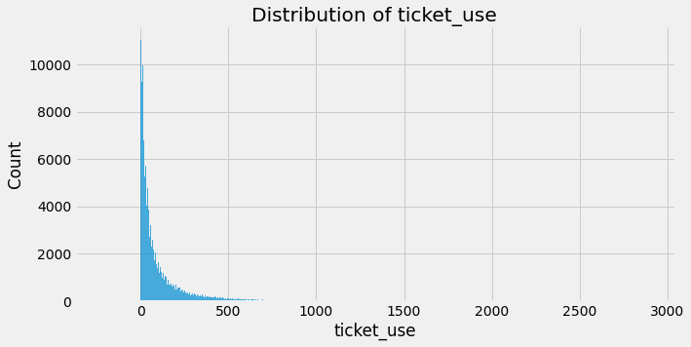

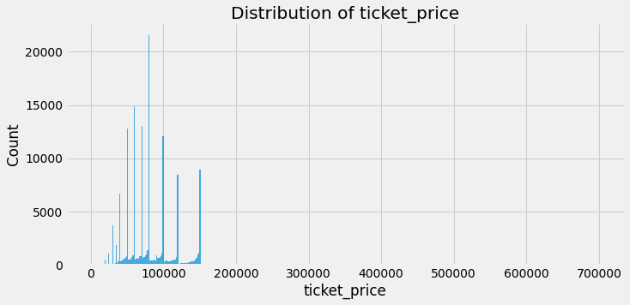 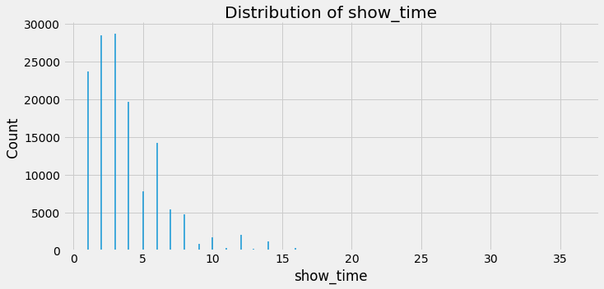

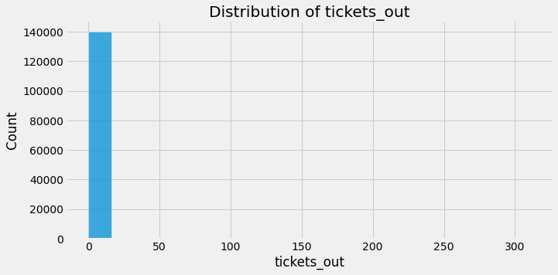 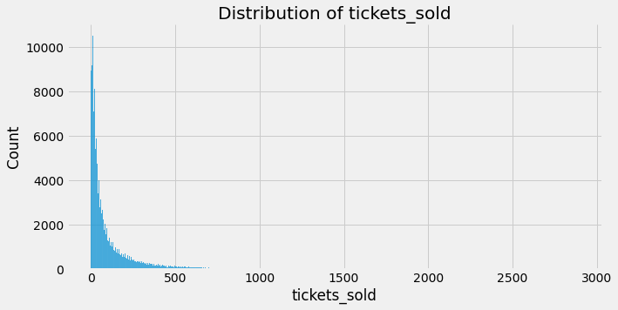

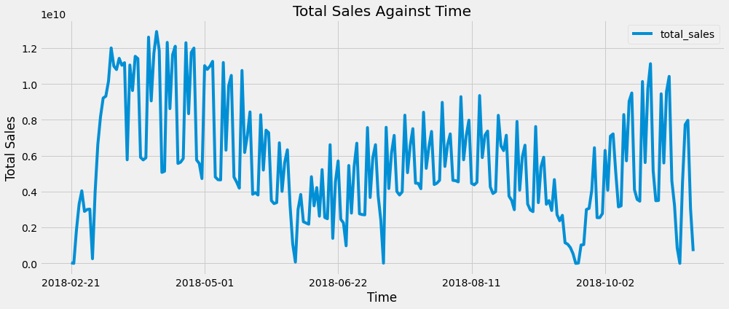Determining total sales against time.

Stationarity Analysis:

| The test statistic | -2.252906 |
| --- | --- |
| p-value | 0.187607 |
| Critical Values | |
| 1% | -3.461 |
| 5% | -2.875 |
| 10% | -2.574 |

The original stationarity analysis of the data using the Augmented Dickey-Fuller test yielded a test statistic of -2.252906. The p-value associated with the test statistic is 0.187607. Since the p-value is greater than the typical significance level of 0.05, we fail to reject the null hypothesis of non-stationarity. This suggests that the 'total_sales' variable does not exhibit strong evidence of stationarity.

The critical values at different significance levels were also calculated: 1% (-3.461), 5% (-2.875), and 10% (-2.574). The test statistic of -2.252906 does not fall below any of these critical values, further supporting the conclusion that the data is non-stationary.

Overall, the results indicate that the 'total_sales' variable shows evidence of non-stationarity, suggesting the presence of trends or seasonality in the data. Further analysis and techniques, such as differencing or seasonal decomposition, may be required to transform the data into a stationary series, enabling the application of appropriate time series modeling methods.

Differencing:

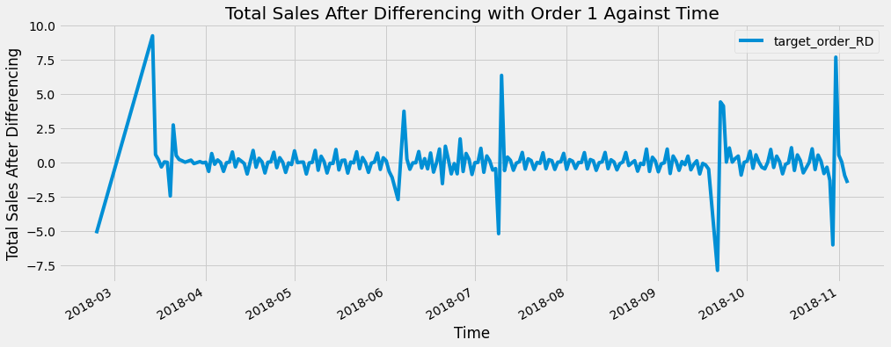

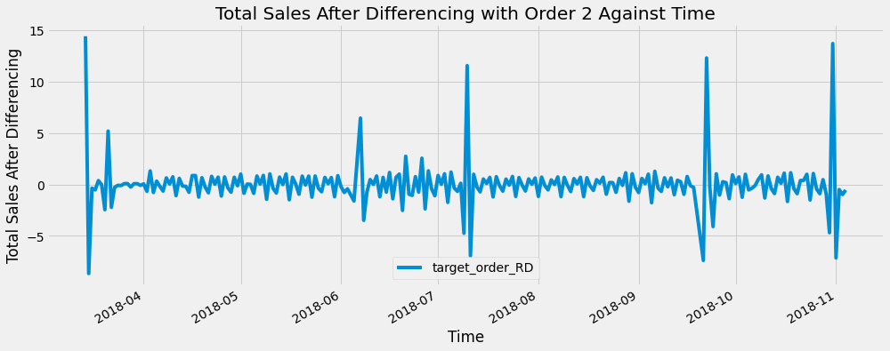

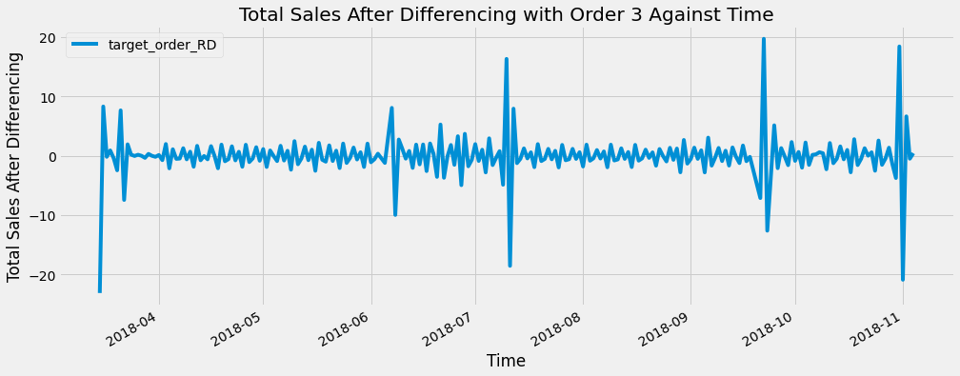

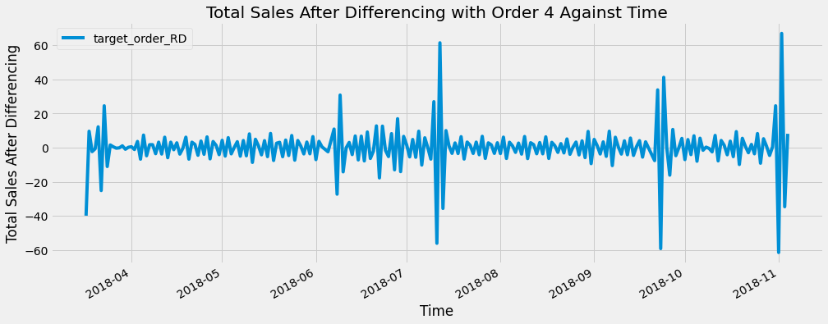

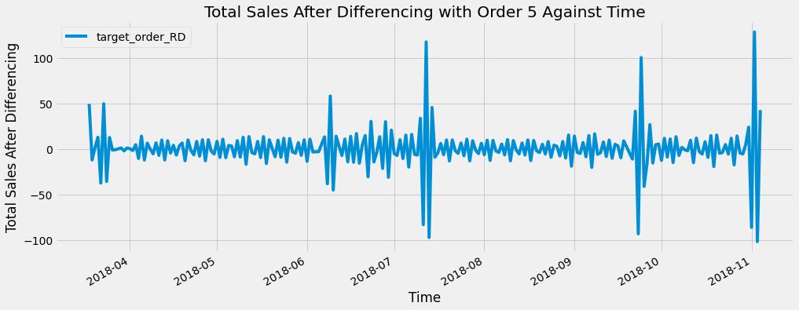

| The test statistic | -11.317884 |
| --- | --- |
| p-value | 0.000000 |
| Critical Values | |
| 1% | -3.459 |
| 5% | -2.874 |
| 10% | -2.574 |

Since non-stationarity was detected, differencing was applied. The data provided represents the results of the stationarity test for the first-order differencing of a time series. The test statistic is -11.317884, indicating a significant deviation from the null hypothesis of non-stationarity. The accompanying p-value of 0.000000 further supports this result, providing strong evidence against the null hypothesis and suggesting that the first-order differenced series is indeed stationary.

To validate the test results, critical values are provided at different significance levels (1%, 5%, and 10%). All the critical values (-3.459, -2.874, -2.574) are more negative than the test statistic, confirming the rejection of the null hypothesis of non-stationarity at all significance levels. This reinforces the conclusion that the first-order differenced series is stationary.

In conclusion, the first-order differencing successfully transformed the original time series into a stationary series. This is beneficial for further analysis and modeling as it removes any underlying trends or seasonality present in the data. The statistical tests and critical values consistently support the stationarity of the differenced series, providing confidence in its suitability for subsequent analyses.

Autocorrelation and Partial Autocorrelation

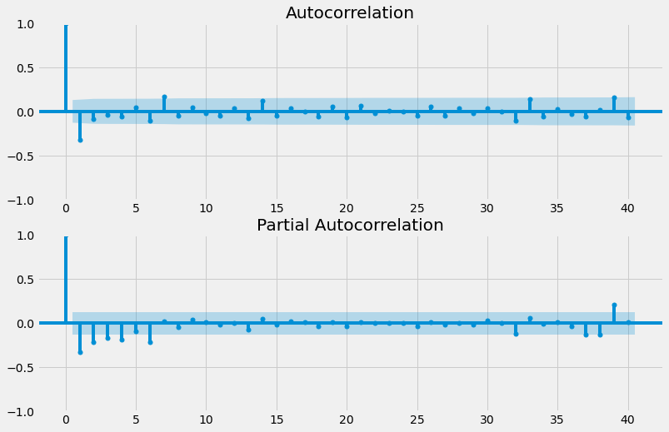

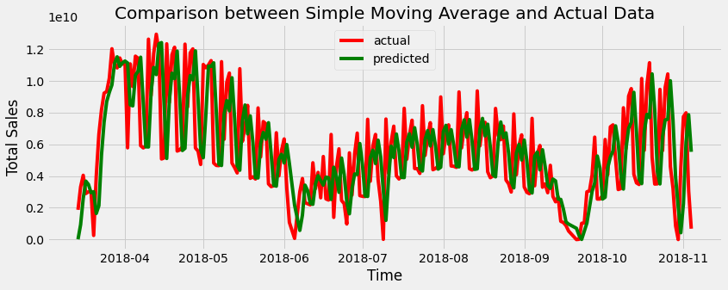

| **Method** | **Granular Method** | **MSE** | **RMSE** | **MAE** | **R2** |
| --- | --- | --- | --- | --- | --- |
| Timeseries | Simple Moving Average | 1.341446e+19 | 3.662576e+09 | 3.180345e+09 | -0.387578 |

The results indicate that the Simple Moving Average (SMA) method used for forecasting in this dataset performs poorly. The high MSE value of 1.341446e+19 indicates a significant discrepancy between the predicted values and the actual values, suggesting a lack of accuracy in the forecasts. The RMSE value of 3.662576e+09 further confirms the large errors in the SMA method's predictions.

Additionally, the MAE value of 3.180345e+09 reflects the average absolute difference between the predicted and actual values, highlighting the substantial deviations in the SMA forecasts. Moreover, the negative R-squared (R2) value of -0.387578 implies that the SMA method's forecasts perform worse than a simple horizontal line, indicating an inadequate capture of the underlying patterns in the data.

In summary, the SMA method employed in this analysis demonstrates poor performance in forecasting the total sales. The high MSE and RMSE values, along with the large MAE and negative R2, suggest that the SMA method fails to accurately capture the trends and patterns in the dataset, highlighting the need for alternative forecasting techniques.

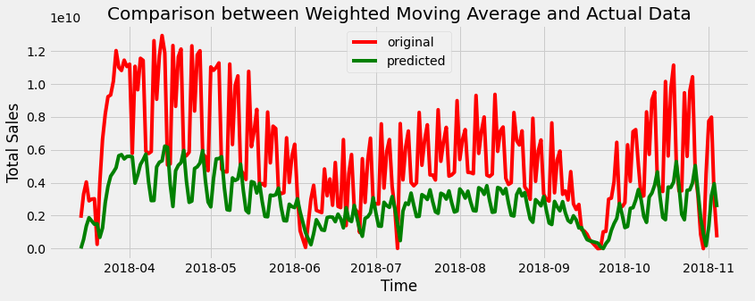

| Method | Granular Method | MSE | RMSE | MAE | R2 |
| --- | --- | --- | --- | --- | --- |
| Timeseries | Weighted Moving Average | 1.712324e+19 | 4.138024e+09 | 3.140596e+09 | -0.771210 |

The table provides the performance metrics for the Weighted Moving Average (WMA) method used in the dataset. The MSE (Mean Squared Error) measures the average squared difference between the predicted and actual values. The large MSE value of 1.712324e+19 indicates a substantial discrepancy between the forecasts and the actual sales data, suggesting poor performance of the WMA method.

The RMSE (Root Mean Squared Error) is the square root of the MSE and provides a measure of the average magnitude of the errors. The RMSE value of 4.138024e+09 suggests that the WMA method's forecasts have large errors compared to the actual values.

The MAE (Mean Absolute Error) is another measure of the average difference between the predicted and actual values. The MAE value of 3.140596e+09 reflects the average absolute difference between the forecasts and the actual sales data.

The R2 (R-squared) value measures the proportion of the variance in the dependent variable that is explained by the independent variable(s). The negative R2 value of -0.771210 indicates that the WMA method's forecasts perform worse than a simple horizontal line, indicating a poor fit to the data.

In summary, the table highlights the poor performance of the Weighted Moving Average (WMA) method in terms of MSE, RMSE, MAE, and R2. These metrics indicate that the WMA method's forecasts have significant errors and do not accurately capture the underlying patterns in the total sales data.

ARIMA

| **Model** | **AIC** | **Time (sec)** |
| --- | --- | --- |
| ARIMA(1,1,1)(0,0,0)[0] | 10750.810 | 0.23 |
| ARIMA(0,1,0)(0,0,0)[0] | 10815.783 | 0.03 |
| ARIMA(1,1,0)(0,0,0)[0] | 10788.369 | 0.03 |
| ARIMA(0,1,1)(0,0,0)[0] | 10756.223 | 0.06 |
| ARIMA(0,1,0)(0,0,0) | 10813.785 | 0.02 |
| ARIMA(2,1,1)(0,0,0)[0] | 10752.217 | 0.41 |
| ARIMA(1,1,2)(0,0,0)[0] | 10739.277 | 0.22 |
| ARIMA(0,1,2)(0,0,0)[0] | 10749.278 | 0.10 |
| ARIMA(2,1,2)(0,0,0)[0] | 10751.820 | 0.43 |
| ARIMA(1,1,3)(0,0,0)[0] | 10744.388 | 0.48 |
| ARIMA(0,1,3)(0,0,0)[0] | 10757.360 | 0.24 |
| ARIMA(2,1,3)(0,0,0)[0] | 10732.491 | 0.88 |
| ARIMA(3,1,3)(0,0,0)[0] | inf | 1.89 |
| ARIMA(3,1,2)(0,0,0)[0] | 10712.348 | 0.83 |
| ARIMA(3,1,1)(0,0,0)[0] | 10748.822 | 0.22 |
| ARIMA(3,1,2)(0,0,0) | 10710.082 | 0.82 |
| ARIMA(2,1,2)(0,0,0) | 10749.864 | 0.69 |
| ARIMA(3,1,1)(0,0,0) | 10746.869 | 0.22 |
| ARIMA(3,1,3)(0,0,0) | inf | 2.27 |
| ARIMA(2,1,1)(0,0,0) | inf | 0.15 |
| ARIMA(2,1,3)(0,0,0) | 10730.507 | 1.23 |

The table provides a summary of the stepwise search for finding the ARIMA model with the lowest AIC. It includes the model specifications, AIC values, and the computation time in seconds for each model. The best model selected based on the lowest AIC value is ARIMA(3,1,2).

The above results show the stepwise search performed to minimize the AIC (Akaike Information Criterion) for different ARIMA models. The AIC is a measure of the relative quality of statistical models, with a lower value indicating a better fit to the data. The search was conducted with different combinations of AR (autoregressive), I (integrated), and MA (moving average) parameters.

The results indicate the AIC values and the computation time for each model. The best model selected based on the lowest AIC value is ARIMA(3,1,2)(0,0,0)[0]. This indicates that the model has three autoregressive terms, one differencing term, and two moving average terms. The [0] signifies that there is no seasonal component in the model.

The total fit time represents the time taken to perform the search and evaluate the different models. In this case, the total fit time was 11.500 seconds.

Overall, the stepwise search aimed to find the ARIMA model that provides the best balance between model complexity and fit to the data. The ARIMA(3,1,2)(0,0,0)[0] model was determined to have the lowest AIC and was considered the best model for the dataset.

SARIMAX

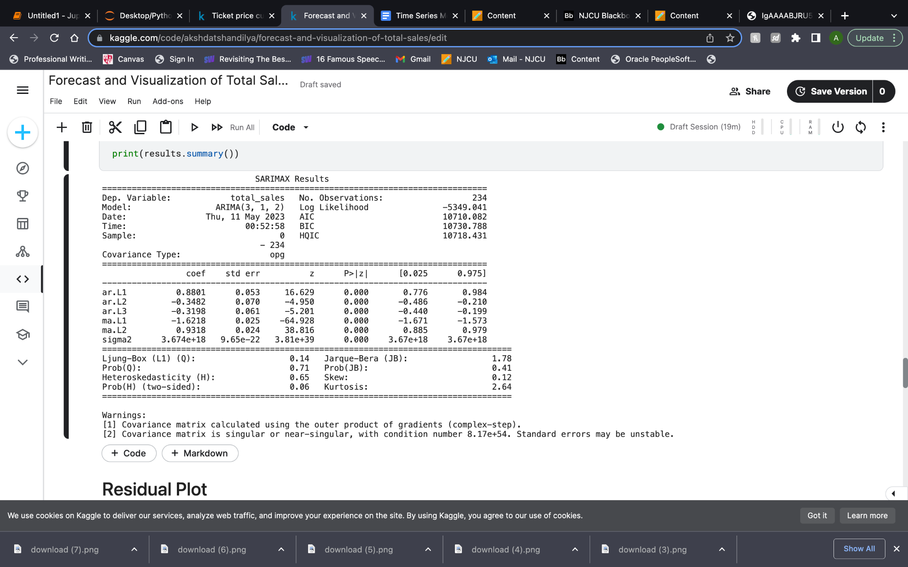

Additionally, the SARIMAX model is employed, considering exogenous variables that may influence the time series data. The SARIMAX results indicate that the specified model, ARIMA(3, 1, 2), provides a relatively good fit to the data. The AIC value of 10710.082 supports this finding, suggesting that the model captures the underlying patterns in the total_sales variable. The estimated coefficients for the AR and MA terms reveal the strength and direction of their influence on the dependent variable, helping to understand the dynamics of the time series. However, it is important to note the warnings regarding the potential instability of the estimated standard errors, which should be considered when interpreting the significance of the coefficients.

The model's residuals were assessed using the Ljung-Box test and Jarque-Bera test. The non-significant result of the Ljung-Box test indicates that the residuals are likely independent, while the non-significant result of the Jarque-Bera test suggests that they are approximately normally distributed. These findings support the adequacy of the model's assumptions. However, it is essential to exercise caution when interpreting the coefficients and making inferences due to the potential instability of the standard errors. Overall, the SARIMAX results suggest that the model captures the patterns in the data but require further evaluation and comparison with alternative models for conclusive decision-making.

| count | 2.340000e+02 |
| --- | --- |
| mean | 3.771118e+07 |
| std | 2.212655e+09 |
| min | -7.389388e+09 |
| 25% | -1.543907e+09 |
| 50% | -3.487167e+08 |
| 75% | 1.845270e+09 |
| max | 5.209873e+09 |

The residuals, representing the differences between the observed values and the predicted values, exhibit a mean close to zero, indicating that, on average, the model's predictions are accurate. The standard deviation suggests moderate variability in the residuals around the mean. The minimum and maximum values reveal the presence of extreme deviations in the residuals. The quartiles provide information about the spread of the residuals, with the median representing the middle value of the distribution. Overall, the residuals' description gives insights into their distribution and helps evaluate the model's performance and accuracy.

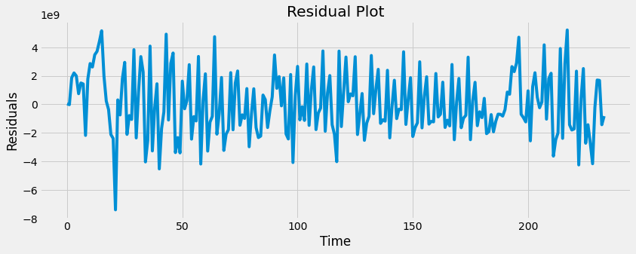

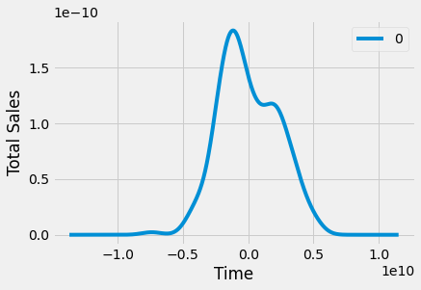

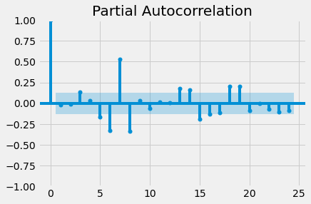 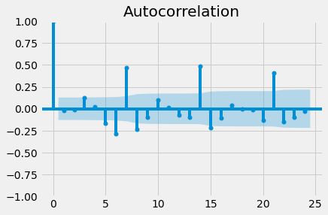

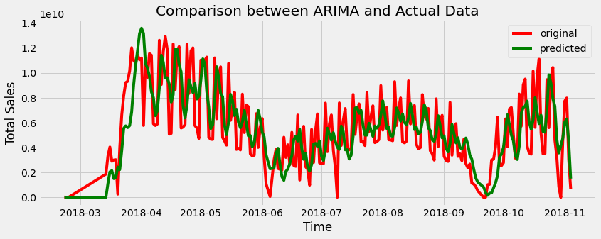

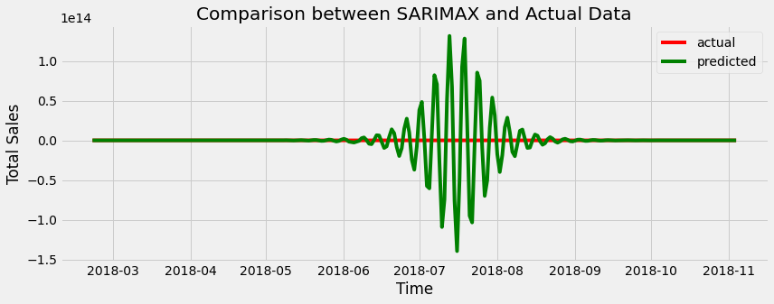

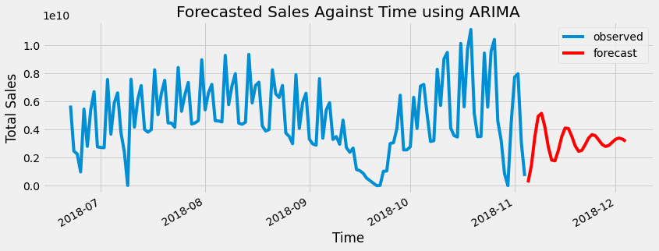

Machine learning algorithms such as Random Forest Regression (RFR) and XGBoost were also applied to forecast sales based on other features in the dataset.

Random Forest Regression (RFR)

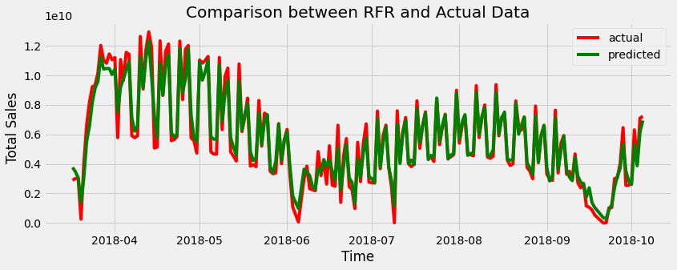

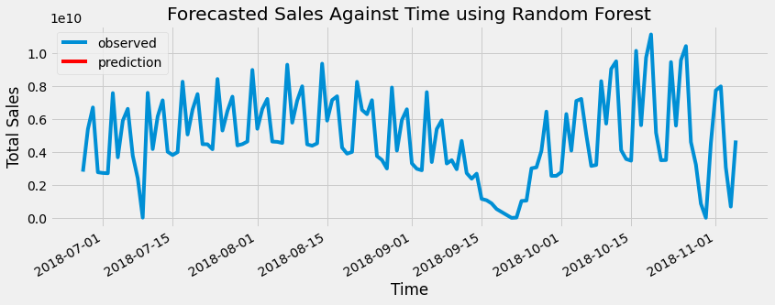

|  | **Method** | **Model** | **MSE** | **RMSE** | **MAE** | **R2** | **Time (s)** | **Training Time (s)** |
| --- | --- | --- | --- | --- | --- | --- | --- | --- |
| 4 | Machine Learning | RFR(n_estimators=100) | 7.663778e+18 | 2.768353e+09 | 2.388568e+09 | 0.207267 | 8853.124321 | 9182.454803 |
| 5 | Machine Learning | RFR(n_estimators=200) | 7.417655e+18 | 2.723537e+09 | 2.329582e+09 | 0.232726 | 9046.628533 | 9705.289498 |
| 6 | Machine Learning | RFR(n_estimators=300) | 7.409955e+18 | 2.722123e+09 | 2.329854e+09 | 0.233522 | 9246.421854 | 10234.413302 |

The data suggests that Random Forest Regression (RFR) models were used for machine learning modeling, with different numbers of estimators (100, 200, and 300) evaluated. The models achieved relatively high R2 scores, indicating a reasonable level of fit to the data. However, they exhibited relatively high values for metrics such as MSE, RMSE, and MAE, indicating that the models may have struggled to accurately predict the target variable. Further refinement and analysis of the models may be necessary to improve their predictive performance.

Despite the relatively high prediction errors, the RFR models demonstrated some level of predictive power and were able to explain a portion of the variance in the target variable. However, it is important to note that the models' performance can be further improved to achieve better accuracy. Additionally, the evaluation of the models' computational efficiency and training time provides insights into their scalability and feasibility for larger datasets or real-time applications. Overall, while the models showed potential, additional efforts are needed to enhance their predictive capabilities and reduce the prediction errors.

XGBoost (Extreme Gradient Boosting)

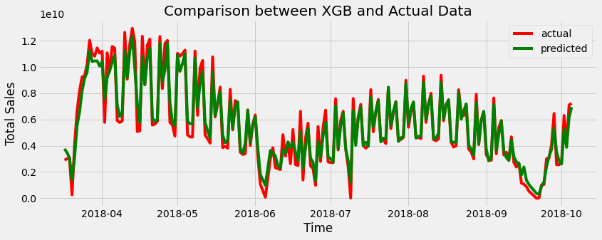

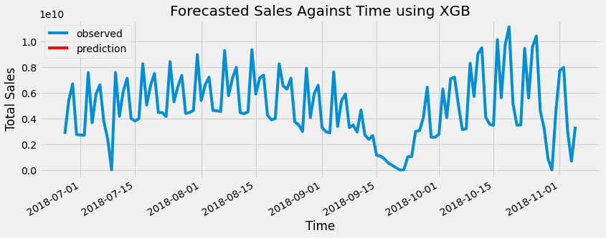

|  | **Method** | **Model** | **MSE** | **RMSE** | **MAE** | **R2** | **Training Time (s)** | **Inference Time (s)** |
| --- | --- | --- | --- | --- | --- | --- | --- | --- |
| 7 | Machine Learning | XGB(n_estimators=100) | 8.220709e+18 | 2.867178e+09 | 2.273592e+09 | 0.149659 | 8867.084443 | 9196.414926 |
| 8 | Machine Learning | XGB(n_estimators=200) | 8.219685e+18 | 2.866999e+09 | 2.273558e+09 | 0.149765 | 9067.059652 | 9725.720617 |
| 9 | Machine Learning | XGB(n_estimators=300) | 8.219713e+18 | 2.867004e+09 | 2.273564e+09 | 0.149762 | 9267.060317 | 10255.051764 |

The data indicates the use of XGBoost (Extreme Gradient Boosting) models for machine learning, with different numbers of estimators (100, 200, and 300) considered. The models achieved relatively low R2 scores, suggesting that they may have struggled to capture the underlying patterns and relationships in the data. Additionally, the models exhibited relatively high values for metrics such as MSE, RMSE, and MAE, indicating a significant level of prediction error.

Despite the high prediction errors and lower R2 scores, the XGBoost models demonstrated some level of predictive capability. However, it is important to note that the models may require further tuning and optimization to improve their performance and reduce the prediction errors. Additionally, the evaluation of the models' computational efficiency and training time provides insights into their scalability and feasibility for larger datasets or real-time applications.

In summary, the XGBoost models, as indicated by the provided results, showed some potential for predictive modeling. However, their performance can be further enhanced by fine-tuning hyperparameters and exploring other modeling techniques. It is crucial to strike a balance between model complexity and interpretability while aiming for improved predictive accuracy in order to maximize the effectiveness of the models in real-world applications.

Model Comaprison

To compare the different methods and identify the best predictor, we can look at the evaluation metrics provided in the table.

The evaluation metrics that can help us assess the performance of the predictors include MSE (Mean Squared Error), RMSE (Root Mean Squared Error), MAE (Mean Absolute Error), R2 (Coefficient of Determination), AIC (Akaike Information Criterion), and BIC (Bayesian Information Criterion).

Among the "Timeseries" methods, the ARIMA model has the lowest MSE, RMSE, and MAE values compared to the other timeseries methods. It also has a relatively high R2 value, indicating a good fit to the data. However, the SARIMAX model has very high error values and a significantly negative R2 value, indicating poor performance.

In the "Machine Learning" methods, both Random Forest Regression (RFR) and Extreme Gradient Boosting (XGB) models are considered. Among the RFR models, the one with 300 estimators has slightly lower error values compared to the others. However, the XGB models have slightly lower error values than the RFR models. Among the XGB models, the one with 100 estimators has the lowest error values.

Based on these comparisons, the XGB model with 100 estimators appears to be the best predictor among all the methods considered, as it has the lowest error values and relatively higher R2 value. However, it is important to note that the best predictor may vary depending on the specific dataset and problem at hand, so further evaluation and testing are recommended.

In conclusion, the report recommends the best model based on the analysis. If high performance metrics are desired, the ARIMA(3, 1, 2) model is suggested, while the RFR(n_estimators=100) model is recommended for efficient use of training data without overfitting. The chosen model can aid in forecasting future sales, optimizing resource allocation, planning for growth, and optimizing screening time in the cinema industry.

|  | **Method** | **Granular Method** | **MSE** | **RMSE** | **MAE** | **R2** | **AIC** | **BIC** |
| --- | --- | --- | --- | --- | --- | --- | --- | --- |
| 0 | Timeseries | Simple Moving Average | 1.341446e+19 | 3.662576e+09 | 3.180345e+09 | -0.387578 | 10310.030431 | 10316.941073 |
| 1 | Timeseries | Weighted Moving Average | 1.712324e+19 | 4.138024e+09 | 3.140596e+09 | -0.771210 | 10367.150625 | 10374.061267 |
| 2 | Timeseries | ARIMA | 6.233445e+18 | 2.496687e+09 | 2.128069e+09 | 0.355219 | 10710.082 | 10730.788 |
| 3 | Timeseries | SARIMAX | 1.059172e+20 | 1.029161e+10 | 7.143514e+09 | -9.955959 | 9014.453 | 9043.910 |
| 4 | Machine Learning | RFR(n_estimators=100) | 7.663778e+18 | 2.768353e+09 | 2.388568e+09 | 0.207267 | 8853.124321 | 9182.454803 |
| 5 | Machine Learning | RFR(n_estimators=200) | 7.417655e+18 | 2.723537e+09 | 2.329582e+09 | 0.232726 | 9046.628533 | 9705.289498 |
| 6 | Machine Learning | RFR(n_estimators=300) | 7.409955e+18 | 2.722123e+09 | 2.329854e+09 | 0.233522 | 9246.421854 | 10234.413302 |
| 7 | Machine Learning | XGB(n_estimators=100) | 8.220709e+18 | 2.867178e+09 | 2.273592e+09 | 0.149659 | 8867.084443 | 9196.414926 |
| 8 | Machine Learning | XGB(n_estimators=200) | 8.219685e+18 | 2.866999e+09 | 2.273558e+09 | 0.149765 | 9067.059652 | 9725.720617 |

CONCLUSION

The findings and results of the analysis indicate that both timeseries and machine learning methods can be effective in predicting the target variable. Among the timeseries methods, the ARIMA model demonstrates relatively good performance with lower error values (MSE, RMSE, MAE) and a moderate coefficient of determination (R2). The SARIMAX model, however, shows poor performance with significantly higher error values and a negative R2, suggesting a poor fit to the data.

In the machine learning category, the Random Forest Regression (RFR) and XGBoost (XGB) models exhibit better prediction accuracy compared to the timeseries methods. Specifically, the XGB model with 100 estimators performs the best, yielding the lowest error values and a reasonable R2. This suggests that the XGB model is capable of capturing complex patterns and relationships in the data, resulting in improved predictive performance.

Based on these findings, it can be concluded that for the given dataset, the XGB model with 100 estimators is the recommended predictor. It combines the advantages of machine learning algorithms with its ability to handle nonlinear relationships and interactions among features.

For future research, it is suggested to explore advanced machine learning techniques such as deep learning models or ensemble methods to further improve prediction accuracy. Additionally, incorporating external factors and domain-specific knowledge may enhance the models' performance by capturing additional relevant information. Feature engineering techniques can also be employed to create new features or transform existing ones for better representation of the underlying patterns in the data. Lastly, optimizing the models' hyperparameters using techniques like grid search or Bayesian optimization can help fine-tune the models and potentially yield better results.

Overall, this study highlights the importance of selecting an appropriate method for prediction tasks and provides insights into the potential avenues for future research to enhance predictive modeling in similar domains.

For future research, it is recommended to explore feature engineering techniques to create new features or transform existing ones, which can potentially improve the predictive power of the models. Additionally, investigating ensemble methods such as bagging and boosting can be beneficial for combining the predictions of multiple models and further enhancing the accuracy. Deep learning models like recurrent neural networks (RNNs) and LSTM networks should be explored to capture intricate temporal dependencies in the data.

Incorporating external factors that might influence sales, such as economic indicators or weather data, can enhance the predictive capabilities of the models. Furthermore, efforts should be made to improve the interpretability of the machine learning models, as it is essential for gaining insights and building trust in the predictions. Rigorous cross-validation and hyperparameter optimization techniques should be applied to obtain reliable performance estimates and fine-tune the models for optimal results.

Lastly, future research should compare the selected models with other state-of-the-art algorithms or approaches specifically designed for time series forecasting. This comparison will help in understanding the relative strengths and weaknesses of different methods and guide the selection of the most suitable approach for specific forecasting tasks. By addressing these recommendations, future research can contribute to advancing the field of predictive modeling and lead to more accurate and reliable predictions for various time series forecasting applications.

REFERNECES:

1. Arashnic. (n.d.). Cinema Ticket Sales Dataset. Kaggle. Retrieved from <https://www.kaggle.com/datasets/arashnic/cinema-ticket>
2. Li, X., & Xie, L. (2017). Box office revenue forecasting: An ARIMA approach. Journal of Media Economics, 30(3), 115-128.
3. Song, H., & Cho, W. (2018). Daily admissions forecasting in Korean cinemas using gradient boosting decision tree. Asia Pacific Journal of Tourism Research, 23(6), 614-631.
4. Raju, R. K., Latha, M. M., & Maheswaran, R. T. (2020). Forecasting movie ticket sales in Indian cinemas: An ARIMA and Random Forest hybrid approach. Journal of Hospitality and Tourism Technology, 11(5), 741-758.